USER MANUAL
SUPER DUTY

GOLF CART
ALL SD Models

CONTENTS
INTRODUCTION……………………………………………………………………………………………………………………………2
SAFETY ADVICE…………………………………………………………………………………………………………………….………3
IDENTIFICATION OF PARTS…………………………………………………………………………………………………….…….4
COMPONENTS AND WIRING DIAGRAM……..………………………………………………………………………………..6
FUNCTIONS OF PARTS……………………………………………………………………………………………………………..…..6
ASSEMBLING THE CART………………………………………………………………………………………………………………..7
OPERATING THE CART…………………………………………………………………………………………………………….……7
BATTERIES AND BATTERY CHARGER………………………………………………………………………………………..…7
MAINTENANCE………………………………………………………………………………………………………………………..…..8
WARRANTY…………………………………………………………………………………………………………………………………..9
TECHNICAL SPECIFICATIONS………………………………………………………………………………………………..……..10

INTRODUCTION
Congratulations on your purchase of an SD-1 model Golf Cart. The SD-1 model series is a mini golf cart designed to be smaller than the normal standard carts. It is for people who want a smaller size cart for easy mobility. These carts incorporate the latest and preferable technologies to suit your mobility needs. We designed this cart to restore the dignity, equality, and personal freedom to provide convenience and comfort to you. Our golf carts provide personal independence whilst ensuring high performance and long life of service. This manual contains important information concerning the safe operation and proper maintenance of your golf cart.
Please ensure that you read this manual carefully. It is important to your safety that you understand the guidelines and instructions given. Your cart should receive regular maintenance according to the schedule outlined in this manual and recommendations from the authorized dealer. By following the maintenance instruction, you will be able to take care of most of your cart’s needs. Should you be unable to correct a fault in your cart, please contact your golf cart dealer immediately.
Above all, follow all service recommendations outlined in this manual to achieve the most trouble free, safe, and enjoyable operation of your cart.

SAFETY ADVICE
- Do not carry passengers or total load exceeding 300KGS
- Do not exceed inclines over 20 degrees.
- Do not make sharp turns on steep slopes.
- Do not turn suddenly at high speeds.
- Do not turn off cart while the cart is in motion.
- Always slow down and proceed carefully when travelling over rough or uneven grounds.
- For individuals driving cart with electromagnetic brake for the first time, should be shown how to use braking system correctly.
- If you’re not used to driving electric golf carts, ask your dealer to reduce the forward speed on the controller to prevent over-speeding and collision.
- Before sitting in or parking the cart, remove the key from the ignition. This will ensure the POWER is off and the cart cannot move under it own power.
- Do not connect any medical or electronic device to the cart battery. This may cause failure of the device, the cart and personal injury.
- Do not drink alcohol and drive or take sedatives while operating your cart.
- Do NOT wash your cart with a hose. Use a damp cloth only.

IDENTIFICATION OF PARTS
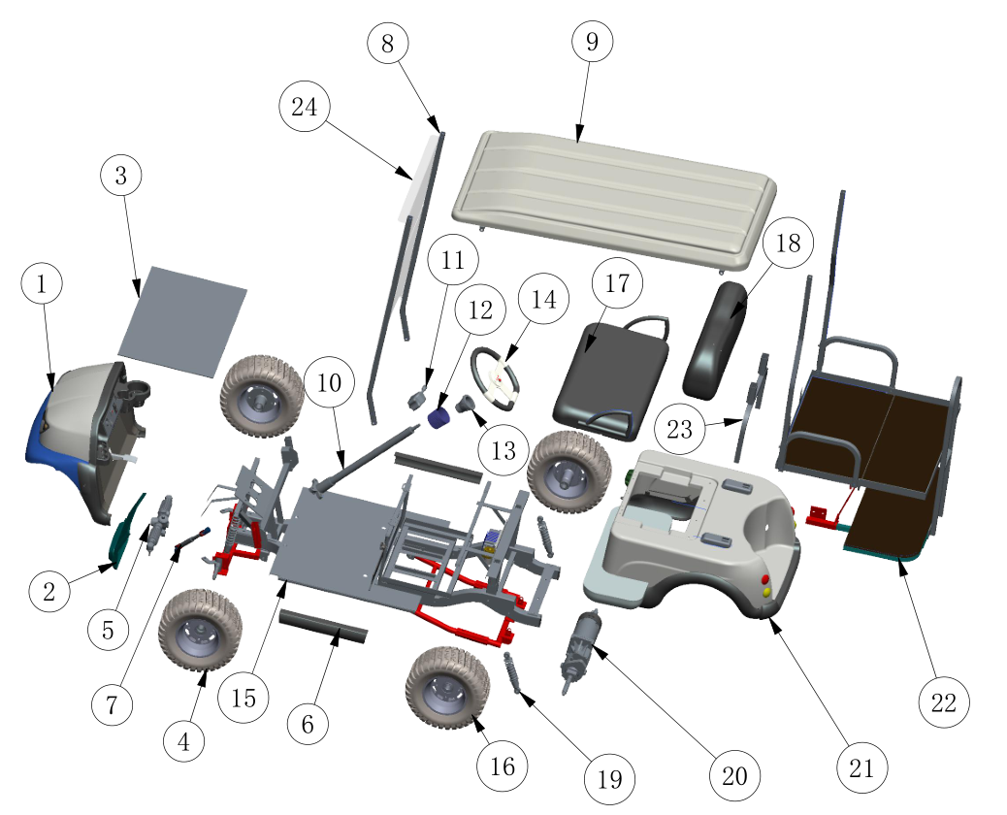
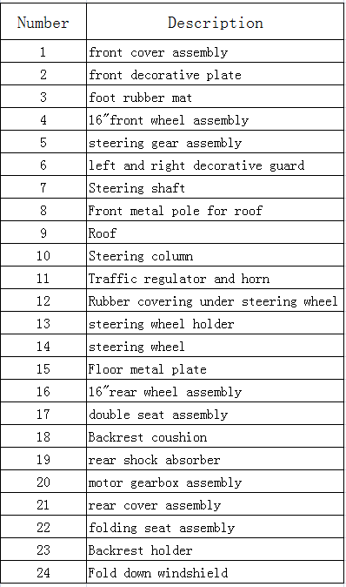
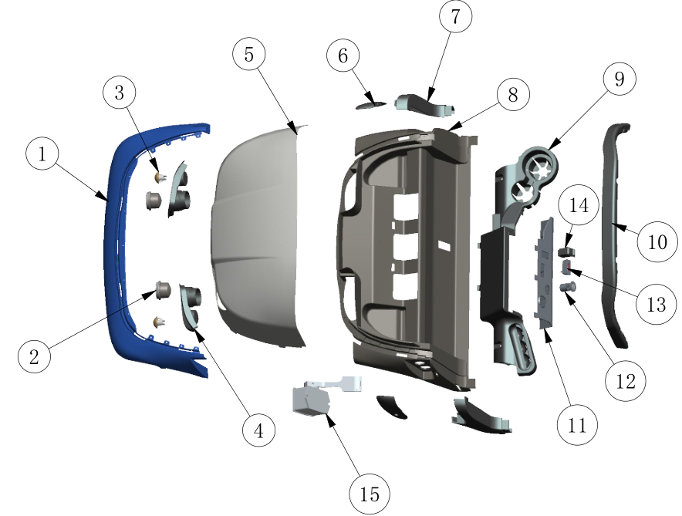

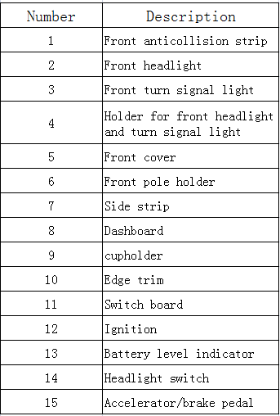

COMPONENTS AND WIRING DIAGRAM
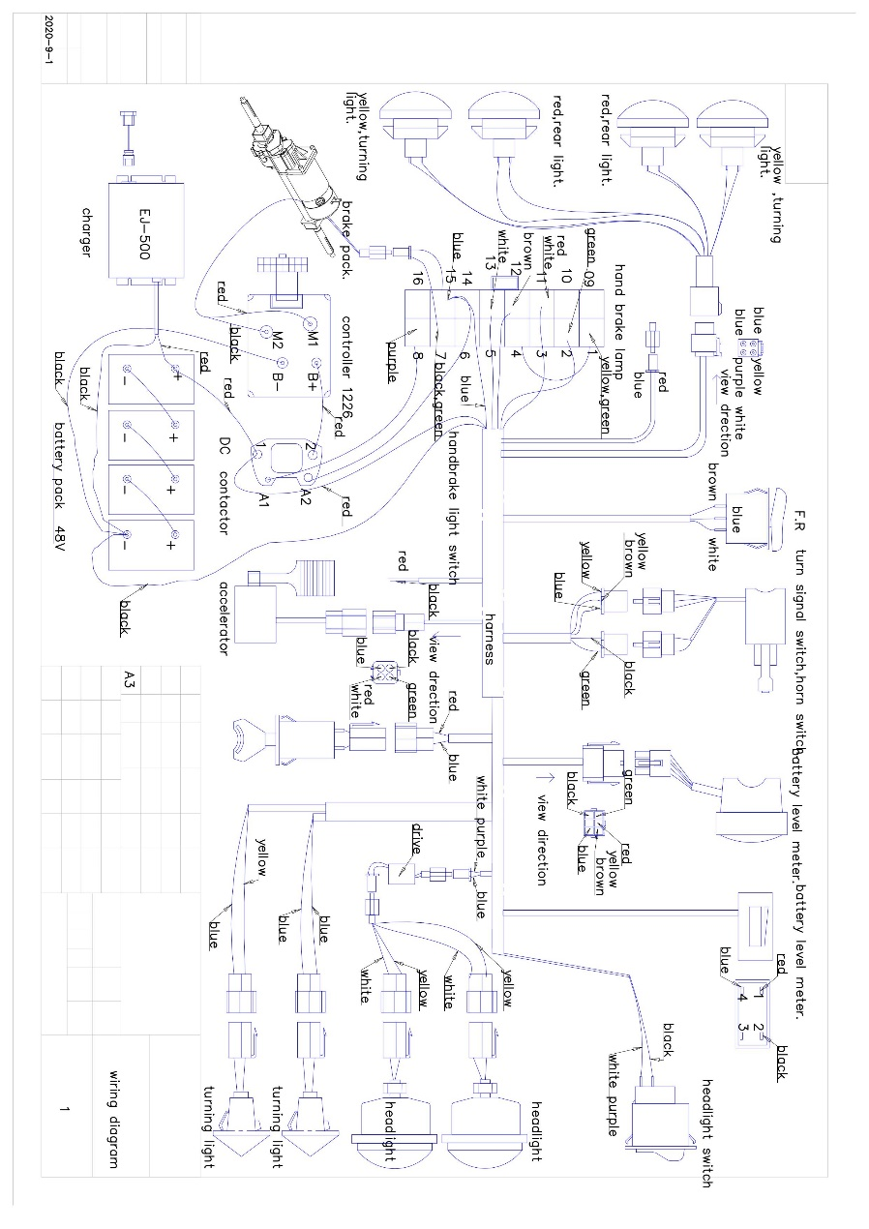
FUNCTION OF PARTS
- Battery gauge: the number of LED bars light shows the amount of charge left in your batteries. The amount of charge will only indicate at its true level when the cart is in drive.
- Do not allow the LED bars to go out completely, as complete discharge of the batteries could cause irreversible battery damage.
- Horn: This button operates the horn.
- On/Off Key Switch: Insert the key in the ignition switch. Turn the key and the LED bars will light up.
- Electromagnetic Brake: The brake is automatically operated when the accelerator pedals are released. You may experience a sharp or slow braking depending on the settings on the controller. Your cart may come with one pedal which functions as accelerator and brake or with a second pedal which also serves as brake pedal.
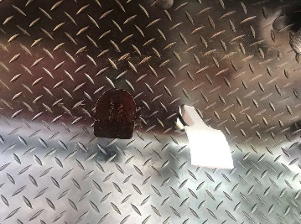
- Forward/Reverse switch: This switch is located right in front of your seat. Press “F” for the cart to move forward and press “R” to reverse the cart.
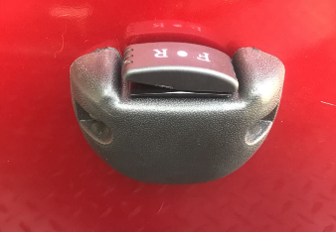

ASSEMBLING THE CART
Usually, your cart will come to you about 80% assembled. The next step is to assemble the accessories, seat, roof and or rear seat with foot plate.
- Assembling the seat
The SD models come in 3 different seats depending on your request. To assemble the rear seat, first fix the two metal points of the backrest correspondently into the joint safely. 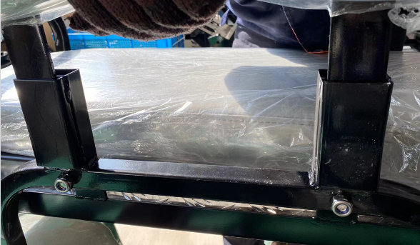
Next, you need to fix the rear seat. Attach the rear seat armrest to the sides of the flip-flop seat then connect the whole rear seat to the metal joints and screw them tightly. See in the pictures below:
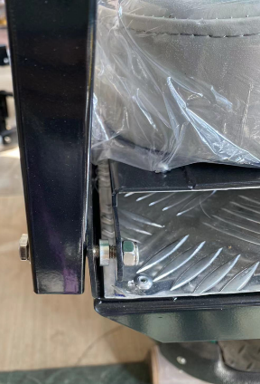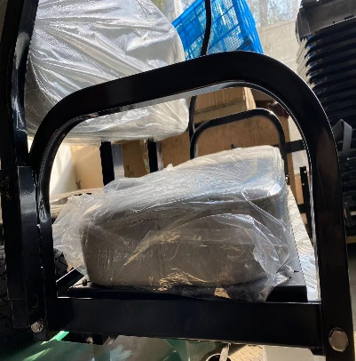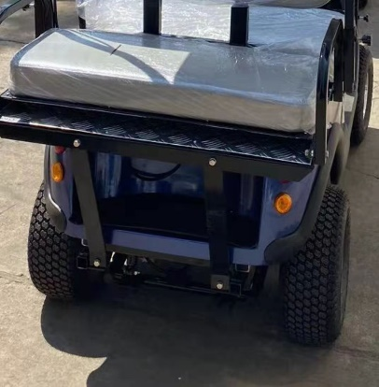

- Assembling the foot plate
The foot plate has a 2-pointer metal. Hook it into the corresponding two joints under the back of the cart. Make sure it is well hooked safely to avoid a shaking discomfort.

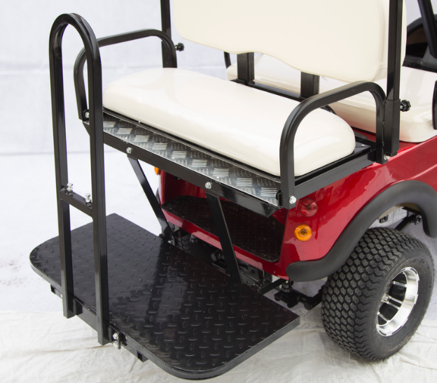
- Assembling the roof
The plastic roof will usually have a rectangular metal ring fixed in it. Assemble the roof on the cart, first insert the rear metal poles into the lower columns attached to the rear seat armrest and screw them up tightly. Next step, fix the front poles on either side of the body with screws. Then with the help of someone, fix the roof on the upper ends of the metals and tighten with bolt and nut.
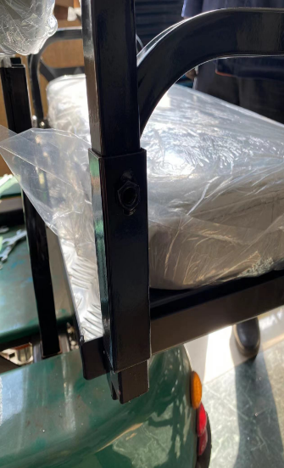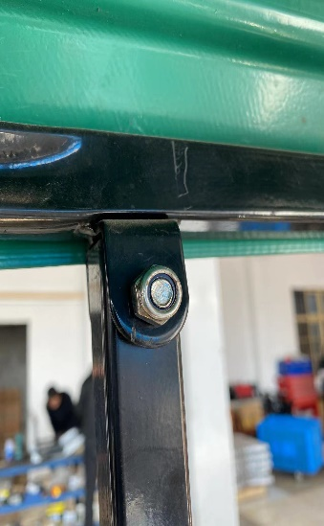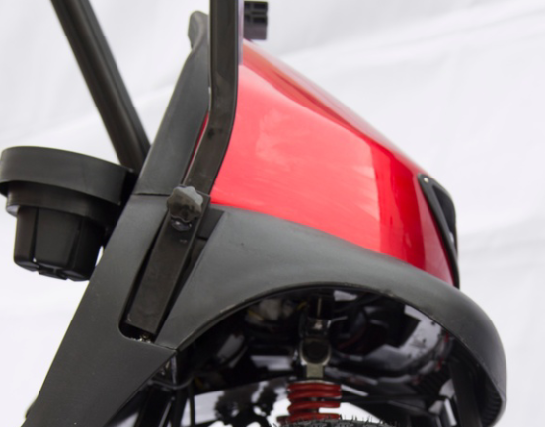
Lower column on rear seat Roof connected to upper end Front pole for roof on the side

OPERATING YOUR GOLF CART
- Before operation
- Insert the key into the power switch and turn clockwise to the ON position.
- Check the battery meter to make sure the batteries are fully charged.
- Make sure the accelerator and brake pedals are in position.

- Turn power ON
Insert the key into the power switch on the dashboard then rotate clockwise to the “ON” position. Allow for the battery lights to come on prior to driving the cart. This allows the controller to initiate its systems check prior to usage.

- Forward motion
To move forward, press “F” on the switch in front of your seat. Next, step on the accelerator pedal slowly for a smooth take off.

- Reverse motion
To reverse, press “R” on the switch in front of your seat. Next, look back or check through your rear-view mirror to know if there is no obstacle behind you. Then slowly step on the pedal to move the cart in reverse.
- STOP
To stop the cart, just release the accelerator slowly. The cart will quietly come to a smooth stop and the electromechanical brake will automatically engage to hold the cart in position on horizontal surface or 20 degree incline surfaces without moving. Quick smooth stops are made possible by the dynamic regenerative braking feature built into the Curtis controller.
Warning:
The electromagnetic brake may not be effective on inclines greater than 20 degrees, downward steep slopes or if the total weight load exceeds 661lbs.
In this case, you may engage the manual brake which may be a second pedal installed on your cart. This will prevent further forward/backwards movement of the cart.
It is always best to be comfortable with the use of electric golf cart before driving it in public space.
BATTERIES AND CHARGER
The golf cart is supplied with maintenance free, sealed Lead Acid Batteries. Battery performance can be affected by temperature, terrain, condition of battery, weight of the user etc. The battery indicator on the dashboard is the only guide and is most effective when the cart is moving. Only then is the true discharge level displayed.
- When the cart stops, the battery level indicator may indicate full.
- Whether the battery level drops or not, the cart must be put on charge after every use. This help to maintain the battery health.
Battery charger
The golf carts come with original chargers of batteries. These chargers are specially designed and have an electronic switch that will terminate the charge when the batteries are fully charged.
To charge the batteries, connect the input end into the battery-charging socket on the cart or battery pack first and then insert the plug into the wall socket.
The battery may take about 6-8 hours to full charge depending on the level of power before charge.

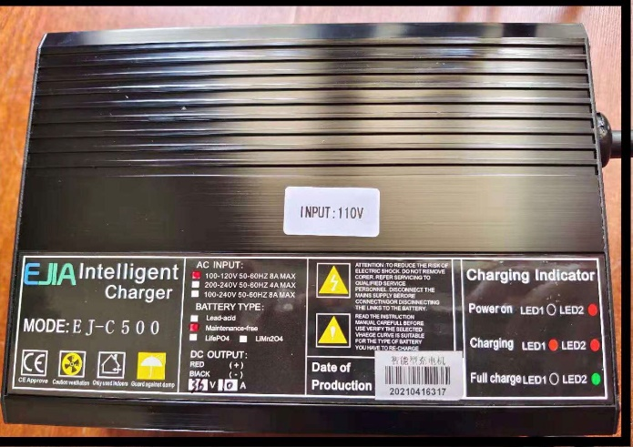

SOLAR PANEL
The solar power acts as a reserved power for the cart. The panel is installed on the roof while the corresponding connectors are wired to the batteries. While using the cart, the panel traps the solar energy and stores it as a reserve. It is simply activated by infusing the two wire points assembled with the cart.
MAINTENANCE
Carry out general maintenance at least every six months whether cart was used or not.
Controller maintenance
The controller of an electric golf cart has no accessory that users can repair, so it’s always advisable not to try to open it to repair. Trying to repair a controller may rather result in permanent damage or reduce the efficiency. Controllers should be used in a dry, clean condition under normal room temperature. Often, you may clean the controller and wipe out any dirt on the surface of the controller.

Rear axle maintenance
Maintenance of the motor and rear axle should be carried out by a qualified technician. Other maintenance tips are:
- Do not overload the cart beyond its capacity.
- Often clean any dirt or corrosive liquid on the surface of the motor.
- The motor is waterproof, but it is not advisable to drive through a pool of water.
- Avoid starting or stopping the motor frequently.

Brake unit
It is advisable to contract a technician or golf cart repair expert to check your brake unit system to ensure that your brake functions properly always.

Wheels and Tires
The wheels of your golf cart all have a single rim, and this allows any punctures to be repaired easily. To change the wheels, remove the center bolts and slide the wheels off its axle. Ensure that when refitting the wheel, the retaining bolt is fitted with a locking washer or the screws or similar adhesive.
When changing a tire, the tube must be deflated. You then will need to break the bead from one side of the tire, then remove the tube or replace. Reinstall by doing the reverse of removal.
Limited Warranty Policy
- All products sold under Mantis Corp, LLC, have been fully inspected prior to being shipped to the customer. Scratches in paint, knicks, dents etc., should be addressed with your freight carrier within 24 hours, as freight damages could occur during shipment to you.
- Mantis Corp, LLC will carry a one-year limited warranty on non-wearable parts from the date of purchase. Examples of wearable parts include tires, lightbulbs, and upholstery. Any parts deemed defective due to workmanship while under warranty will be replaced by Mantis Corp, LLC.
- Batteries and electronic systems have a 6 month warranty.
- Should your cart need to be repaired, please take it to your local golf cart dealer. They will be able to diagnose the problem if they have a Curtis 1313 scanner. Mantis Corp, LLC will need to authorize the repair in writing prior to the work being done. Once a solution has been identified, the defective parts must be received within 14 days after written authorization is received. There will be no credit after the 14-day window.
- Once Mantis Corp, LLC receives the defective part and finds it to be a warranty issue, you will be credited for the charge. Any labor associated with the replacement of warrantied parts is not covered under the warranty.
- The warranty is non-transferrable, should the customer decide to sell the cart within the warranty period.
- Mantis Corp, LLC will not be held accountable for negligence or any type of vandalism to the cart.
- Mantis Corp, LLC will not be liable for any damage that occurs while under the influence of alcohol, or drugs of any kind, including prescription drugs, that may result in bodily injury or damage to the cart. The customer is responsible for maintaining and operating the cart per the owner’s manual as to not void the warranty.
- Modifications to the cart must have written permission from Mantis Corp, LLC to prevent voiding the warranty.
- Lack of care such as jumping, pulling excessive weight on the frame, or towing will also void the warranty.
- Damage that occurs while the customer is transporting the cart will void this warranty.
- Mantis Corp, LLC will not accept returns of carts that may be repaired through the warranty process.
Returns/Cancellations
All returns and cancellations are at the discretion of Mantis Corp, LLC. Non returnable items include :
- Accessories
- Custom products
- Special orders
- Discontinued parts
- Clearance or “sold as Is” products

- Should we allow the return of the cart, it must be returned in the same condition as it was shipped to you. The cart will have no dents, scratches, broken lights, flat or scraped tires, no stains, or tears in the upholstery.
- The cart will be shipped and insured at the expense of the customer in its original packaging and crate to Mantis Corp, LLC. There will be a 25% restocking fee if we deem the product is returnable to us.
- Once we receive the cart from the customer, any damage incurred during the return process will be charged to the customer to include both labor and parts.
- Credit card transaction fees will be imposed should you cancel your order.
- If you cancel your order, any custom colors or body wrap fees will not be refunded to you.
Please research warranty, cautions and disclaimer information in the owner's manual that is included with the cart from Mantis Corp, LLC and call for any and all assistance that you may need.

TECHNICAL SPECIFICATIONS
DESCRIPTIONS | PARAMETERS
Heavy Duty Motor/Trans | 48V 2000W
Lead acid battery | 12V 55Ah *4
Solar panel | 170W
Curtis controller | 48V 400A
Forward speed | 13 MPH
Reverse speed | 4.9 MPH
Range | 52 Miles
Gross weight | 793 lbs.
Net weight | 727lbs.
Load capacity | 661lbs.
Overall dimension | 72.8*37.4*44.9 in.
Incline capability | 20 degrees
Wheel size | 16*6.50-8
Hydraulic Fluid Shocks | Smoother Ride/Stability
Brake | Electromagnetic and front drum brakes

